

**YOGA CENTER**

**Software Design Document**

– HCM, May 2023 –

**Table of Contents**

I. Overview 3

1. Code Packages 3

2. Database Schema 3

II. Code Designs 4

1. <Feature/Function Name1> 4

a. Class Diagram 4

b. Class Specifications 4

c. Sequence Diagram(s) 4

d. Database queries 5

2. <Feature/Function Name2> 5

III. Database Tables 5

1. <Table name 1> 5

2. <Table name 2…> 5

# I. Overview

## 1. Code Packages/Namespaces

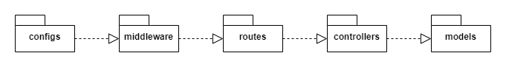

***Package descriptions & package class naming conventions***

|  |  |  |
| --- | --- | --- |
| **No** | **Package** | **Description** |
| 01 | configs | * The directory contains the application's configuration files. * lowercase (ex: config.js) |
| 02 | middleware | * Directory containing middleware files, used to perform processing tasks before the request reaches the destination. * camelCase (ex: userMiddleware.js) |
| 03 | routes | * The directory contains the route files to handle requests from the client and call the functions in the corresponding controller. * snake-case (user-routes.js) |
| 04 | controllers | * Directory containing file controllers to control application logic. * camelCase (ex: userController.js) |
| 05 | models | * Directory containing model files that define the database structure and methods for interacting with the database. * camelCase (ex: userModel.js) |

## 2. Database Schema

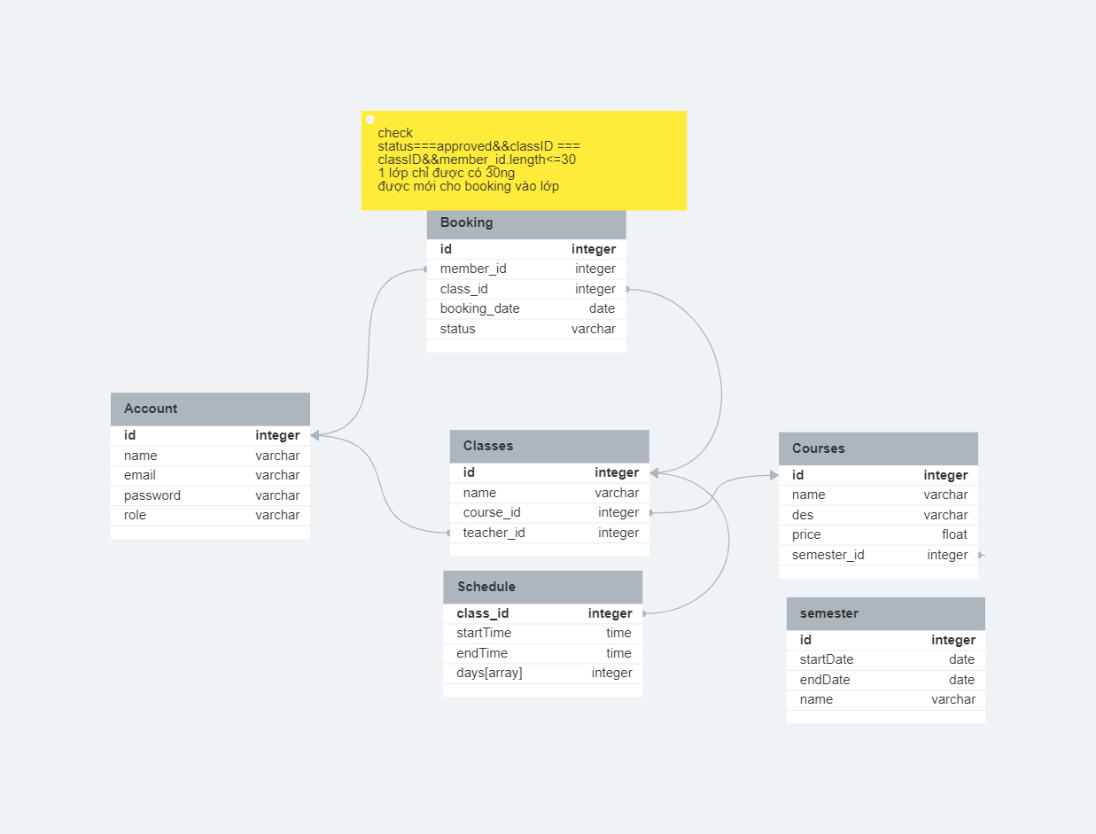

***Table descriptions & package class naming conventions are as below***

|  |  |  |
| --- | --- | --- |
| **No** | **Table** | **Description** |
|  | Account | * Contains information of all accounts logged into the shop * Primary key: account_id |
|  | Booking | * Contains all information of customer booking * Primary key: booking_id * Foreign keys: account_id, class_id |
|  | Classes | * Contains information of all classes in charge of the instructor * Primary key: class_id * Foreign keys: courses_id |
|  | Schedule | * Contains information of customer, staff schedule * Foreign keys: class_id |
|  | Courses | * Contains all information courses available * Primary key: courses_id * Foreign keys: semester_id |
|  | Semester | * Contains information of course in each semester * Primary key: semester_id |

# II. Code Designs

## 1. <Feature/Function Name1>

*[Provide the detailed design for the function <Feature/Function Name1>. It include Class Diagram, Class Specifications, and Sequence Diagram(s)]*

### a. Class Diagram

*[This part presents the class diagram for the relevant feature]*

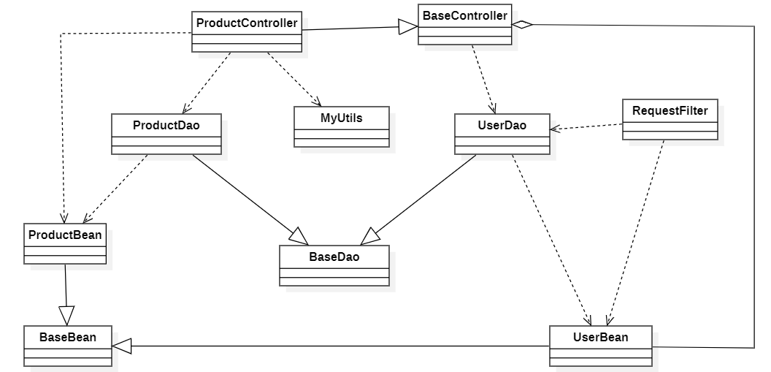

### b. Class Specifications

*[Provide the description for each class and the methods in each class, following the table format as below]*

#### XYZ Class

*[Provide the detailed description for the class methods]*

|  |  |  |
| --- | --- | --- |
| **No** | **Method** | **Description** |
| *01* | *<method name>* | *<Description of the method, including the inputs, outputs & internal method processing>* |
|  |  |  |

#### ABC Class

***Class Methods***

*[Provide the detailed description for the class methods]*

|  |  |  |
| --- | --- | --- |
| **No** | **Method** | **Description** |
| *01* | *<method name>* | *<Description of the method, including the inputs, outputs & internal method processing>* |
|  |  |  |

### c. Sequence Diagram(s)

*[Provide the sequence diagram(s) for the feature, see the sample below]*

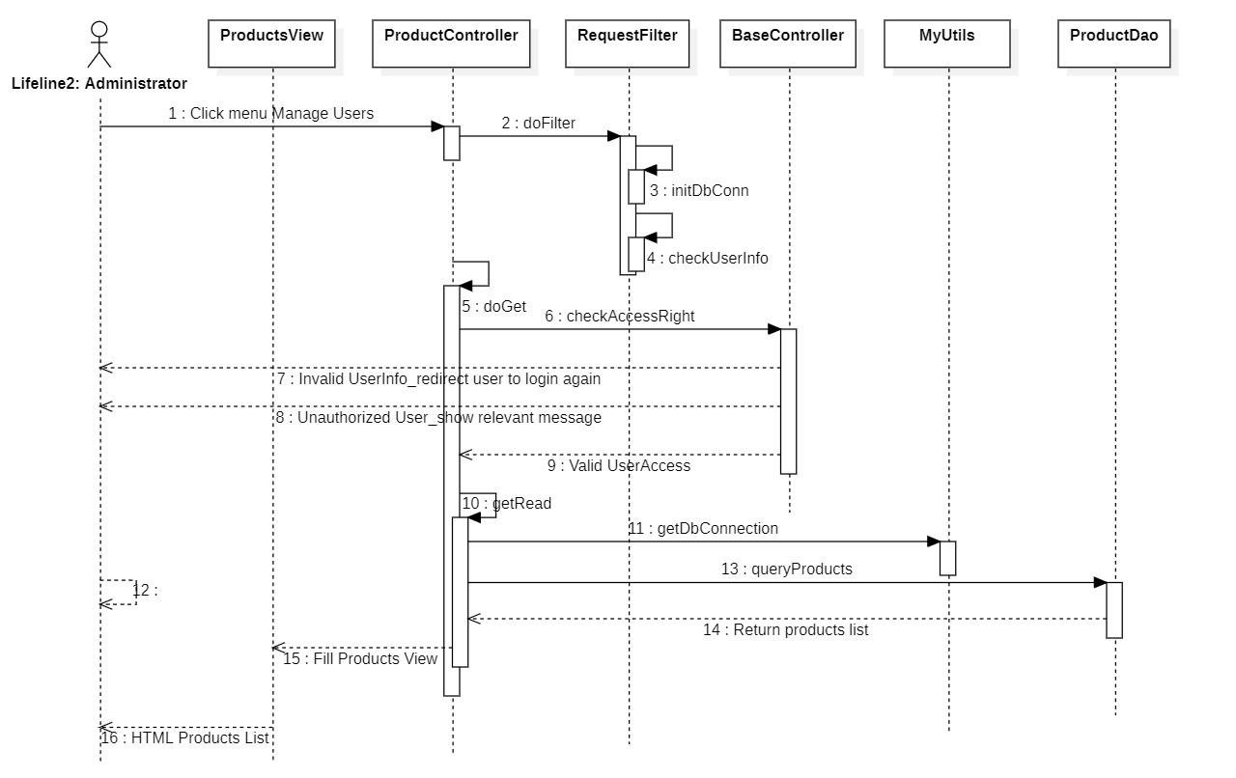

### d. Database queries

*[Provide the detailed SQL (select, insert, update...) which are used in implementing the function/screen]*

## 2. <Feature/Function Name2>

…

# III. Database Tables

## 1. <Table name 1>

*[Give some lines about the table here>>*

*[Table fields, in the form of table format as below]*

|  |  |  |  |  |  |  |  |
| --- | --- | --- | --- | --- | --- | --- | --- |
| **#** | **Field name** | **Type** | **Size** | **Unique** | **Not Null** | **PK/FK** | **Notes** |
| 1 | Field name1 |  |  |  |  |  |  |
| 2 | Field name2 |  |  |  |  |  |  |

## 2. <Table name 2…>